August Social Media Content
Download images here: https://wppienergy.org/services/social-media-support/

August: Affordable Power
Post copy: Pay less with local utilities. We’re here to help you manage your energy costs – while also managing ours. System upgrades, reduced operational costs and long-term planning all come back to you as savings that stay in our community. We deliver low-cost, reliable electricity you can count on.



August: Back to School

Post copy: Reduce the impact your back-to-school shopping has on energy and the environment by making a few simple choices.
Reduce: Reduce the number of new items you're buying. Take inventory of the school supplies already on hand from last year and make sure not to waste money on new items that you don't need.
If you're planning to purchase computers or electronics, be sure they are ENERGY STAR qualified to ensure they use as little energy as possible.
Reuse: Think of the items your household consumes and invest in their reusable counterparts. Take 180 brown paper bags and plastic bottles off the road — send each kid to school with a reusable lunchbox and water bottle!
Recycle: Look for paper notebooks, reusable food storage items and even clothes made from recycled materials!

August: Take a Load Off
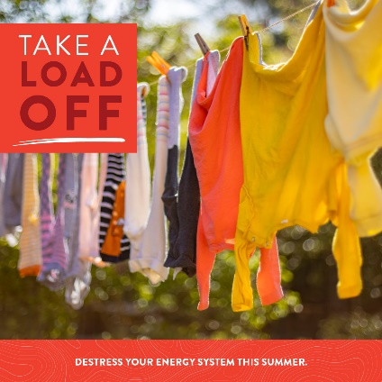
Summer is the most stressful time on our electric system. Protect your home and your wallet from the stresses of summer with the help of these simple tips:
Go Au-Natural – Hang clothes on the line instead of than running the dryer.
Fire up the grill – Using your stovetop or oven can really put a strain on your air conditioner and electric system. Save some dough and maintain comfort by firing up the grill.
Go Unplugged – Vampire power can suck up to 5% of your power bill or more. Unplug TVs, computers, microwaves, and cell phone chargers, or plug them into a power strip and flip them off when not in use.
Stay Out of the Spotlight – Boost security and savings by updating outdoor lighting fixtures with motion sensors, timers and photocells for sensing daylight.


August: Energy Education
Empowering Wisconsin’s Future! We are proud to partner with schools and communities to support and promote energy education.
K-12 Energy Education Program (WI)
Wisconsin’s K-12 Energy Education Program, or KEEP, provides a variety of professional development workshops to enhance the integration of energy education into existing curricula. Through teaching units, workshops, and scholarships, KEEP strives to provide a strong network of information to support ongoing education efforts in our community.

National Theatre for Children
The largest in-school touring educational theatre company is a popular and successful tool in educating students on important energy issues. The live performances focus on energy management, safety and renewable energy and typically visit our local schools in the spring. Additional resources are provided to teachers to transfer the topics into lesson planning.

