COVID-19 Community Recharge Program
Customer Communications

Social Media Posts

Post copy: Now more than ever, our commitment to the people and businesses we serve goes beyond safe and reliable energy. You can count on us to stand by our community. To aid local relief efforts, the utility made a donation of $[XXXX] to [Please insert a description of the donation recipient and purpose.] #rechargetogether #recharge[communityname] #wepoweron #communitypowered

Post copy: The current public health emergency has increased the level of help people need from some of our community’s most vital support organizations and we want to do our part to help them recover. To aid local relief efforts, the utility made a donation of $[XXXX] to [Please insert a description of the donation recipient and purpose.] #rechargetogether #recharge[communityname] #wepoweron #communitypowered

Post copy: To aid in COVID-19 relief efforts, we are partnering with [organization name] as part of our Community Recharge Program to help address the local health and economic impacts of COVID-19. [Please insert a description of the donation recipient and purpose.] #rechargetogether #recharge[communityname] #wepoweron #communitypowered

If desired, please choose from or edit the following options to best meet your utility’s local messaging needs/preferences for describing the funding source.

- [Utility Name] is donating the Community Recharge funds in partnership with its not-for-profit, member-owned wholesale power supplier, WPPI Energy, in order to help address the local health and economic impacts of COVID-19.
- [Utility Name]’s Community Recharge funds were provided by the community’s member-owned, not-for-profit wholesale power supplier, WPPI Energy. WPPI established the Community Recharge program to help its membership address the local health and economic impacts of COVID-19.

Images ideas:
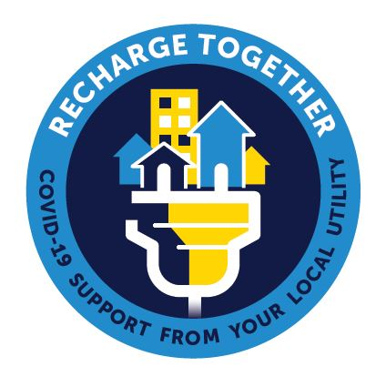

Tips:
- Use a local image when sharing your donations and contributions to local COVID-19 relief efforts to communicate authenticity.
- Acknowledge the organizations and/or highlight the work they are doing in your community as you provide donations. Thank the organization and tag them in your post, pending approval from the organization, to help show the community how they are making a difference.
- The purpose of sharing your goodwill is to inspire others. Be authentic and connect with organizations and your customers!

Website article

Community Recharge Funding Provided to [recipient organization name]

The current COVID-19 public health pandemic has increased the level of help needed from some of our community’s most vital support organizations. [Member Utility Name] has dedicated “Community Recharge” funds to support our community’s pandemic relief efforts and help these important organizations maintain their critical community services.

To enhance current local relief efforts, we have made a donation of $[XXXX] to [insert a 2-3 sentence description of the donation recipient and purpose, include a link to the recipient’s website].

[Utility Name]’s commitment to the people and businesses we serve goes beyond safe and reliable energy. You can count on us to stand by our community. As you always have.

